**项目名称：Steps of the process**

**作者：Dos Cocos Locos Productions**

**来源：**[**https://www.pinterest.com/pin/8303580553811381/**](https://www.pinterest.com/pin/8303580553811381/)

**概要描述：**Typography forming steps. Font: Aktiv Grotesque. Made in Adobe After Effects.

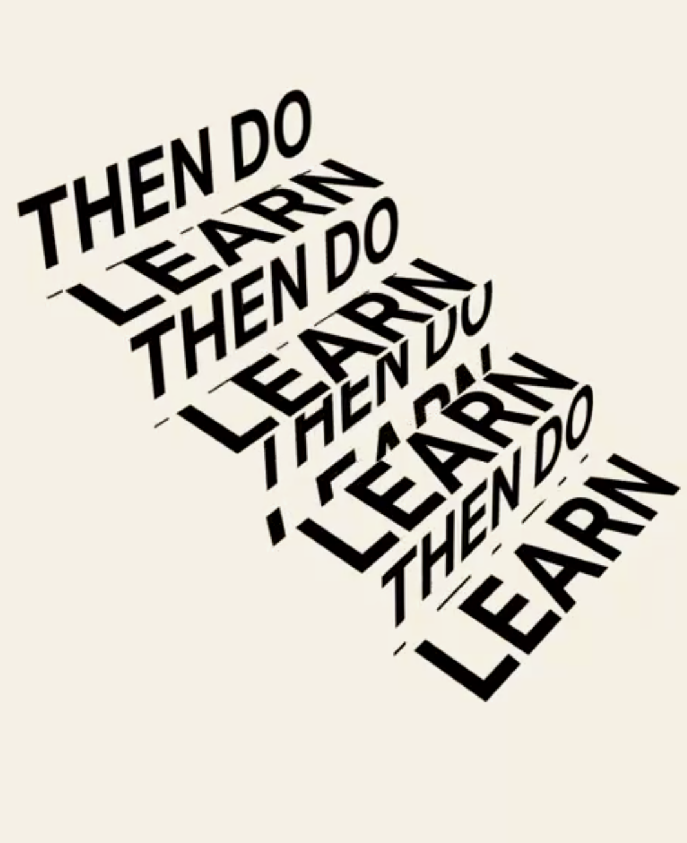**截图：**

**项目名称：’Grateful’ Print**

**作者：**

**来源：https://www.pinterest.com/pin/841962092848140577/**

**概要描述：**

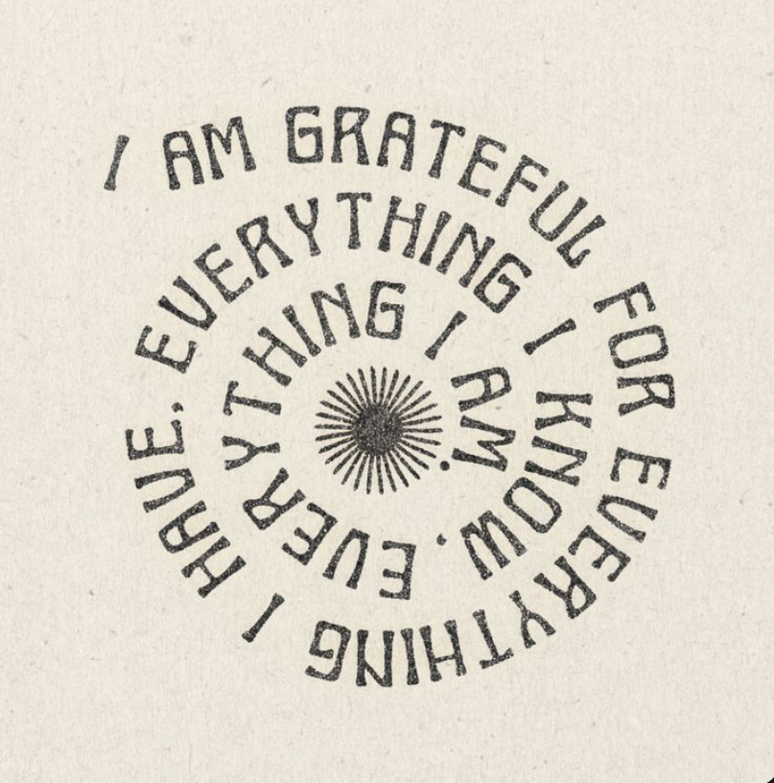**截图：**

**项目名称：Metal Poster Never Give Up Neon Sign**

**作者：**

**来源：**[**https://www.pinterest.com/pin/332422016264906388/**](https://www.pinterest.com/pin/332422016264906388/)

**概要描述：**

**截图：**

